# Git Lab

1. **Git Configuration**

Configure Git with user details:

git config --global user.name "Your Name"

git config --global user.email "[youremail@example.com](mailto:youremail@example.com)"



# Create a New Repository

mkdir my-git-project

cd my-git-project git init

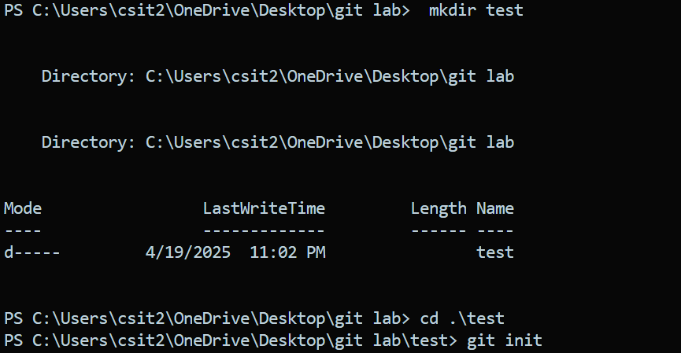

# Check Repository Status

git status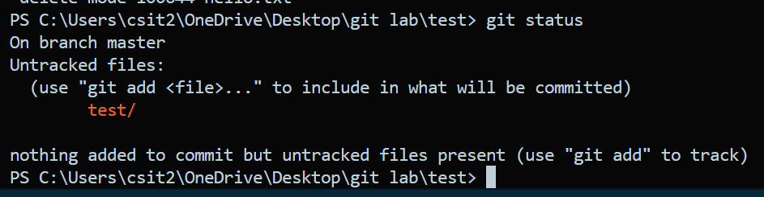

# Create and Add a File

echo "For Git" > hello.txt

git add hello.txt

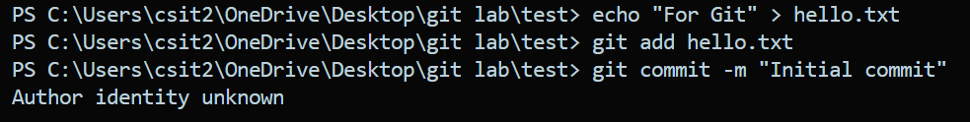

# Commit Changes

git commit -m "Initial commit"

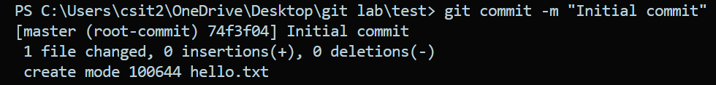

# View Commit History

git log

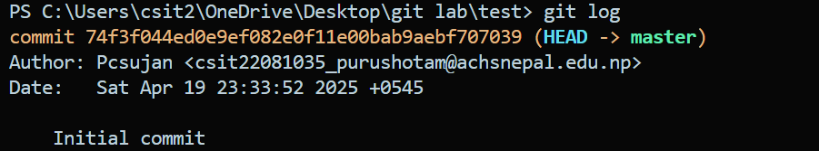

# Create a New Branch

git branch new-feature



# Switch to the New Branch

git checkout new-feature



1. Check all available branches

git branch

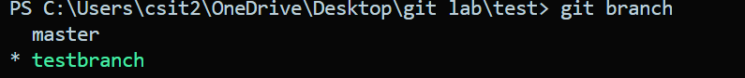

# Merge Branches

Switch back to the main branch and merge:



git checkout main

git merge new-feature



# Add a Remote Repository

git remote add origin <https://github.com/username/my-git-project.git>

git remote add origin <https://github.com/1kalyan/try.git>

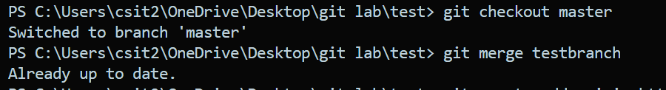

# Push to Remote Repository

git push -u origin main



# Clone a Repository

git clone <https://github.com/username/my-git-project.git>

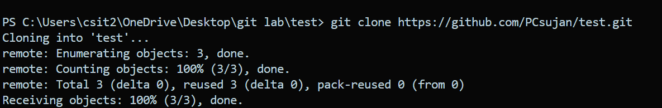

# Disconnect from Original Remote

git remote remove origin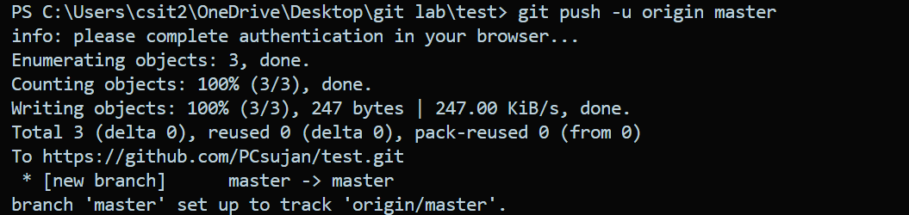

# Pull Latest Changes

git pull origin main

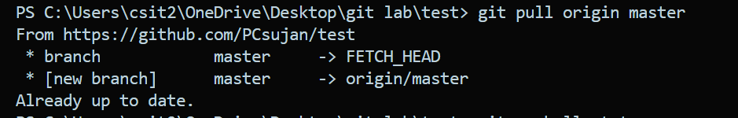

# Remove a File

git rm filename.txt

